Honda Manufacturing of Indiana (HMIN)

Information Services

EI_PA Headless terminal Test Plan
Version 1.0

Creation Date: 3/07/2012 8:26:00 AM

Last Saved: 10/17/2012 5:33:00 PM

TABLE OF CONTENTS

1. Revision History 3
2. Document Overview 4
2.1. Referenced Documents 4
2.2. Acronym List 4
3. Environment 4
4. Test Execution 5
4.1. Test Case 1 – Normal functioning of EI_PA terminal 5
4.1.1 Pre-Conditions 5
4.1.2 Purpose 8
4.1.3 Major Tables 8
4.1.4 Test Steps 8
4.1.5 Post-Conditions 13
4.2. Test Case 2 – Modify Inventory Update interval 14
4.2.1 Pre-Conditions 14
4.2.2 Purpose 14
4.2.3 Major Tables 14
4.2.4 Test Steps 14
4.2.5 Post-Conditions 18

Revision History
Revision | Section | Description | Editor | Date
1.0 | All | Original | Subu Kathiresan | 3/07/12
Reviewers
Name | Position | Version | Comments
Approval Signatures
Name | Position | Version | Signature / Date

Document Overview
This section describes the process that this test plan exercises.

Referenced Documents
The following documents are referenced as part of this document.
- CurrentInventory.sql
- EI_PA.opf

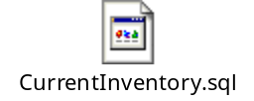

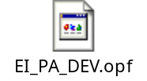

Acronym List
- GALC – Global Auto Line Control
- HMIN – Honda Manufacturing of Indiana
- HAM – Honda of America, Mfg.
- HMA – Honda Manufacturing of Alabama
- VIN – Vehicle Identification Number
- PL – Project Lead
- WE – Weld department
- ST – Stamping department
- AF – Auto Frame department
- VQ – Vehicle Quality department

Environment
This section describes the environment that the test was executed against.

Environment | WAS Version | App Server | DB Server | OPC Server | Device

Test Execution

Test Case 1 – Normal functioning of EI_PA terminal

Pre-Conditions
- The EI_PA terminal must be setup in configuration services

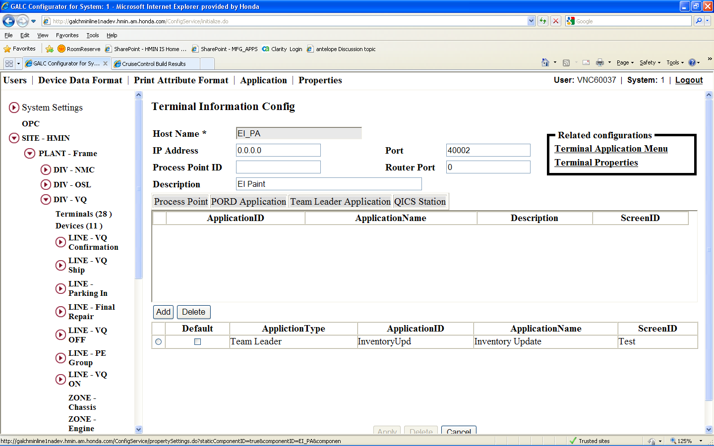

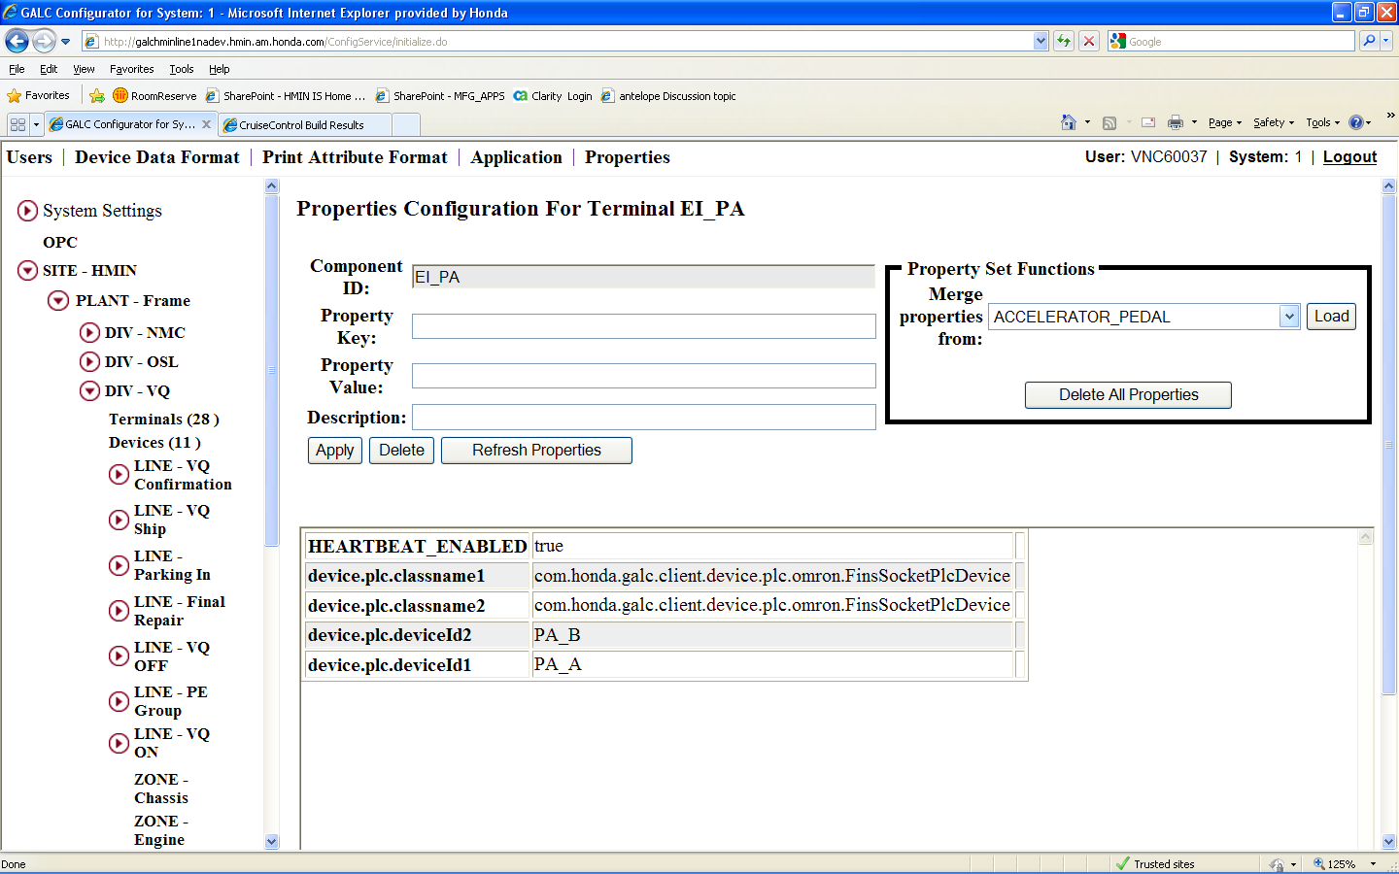

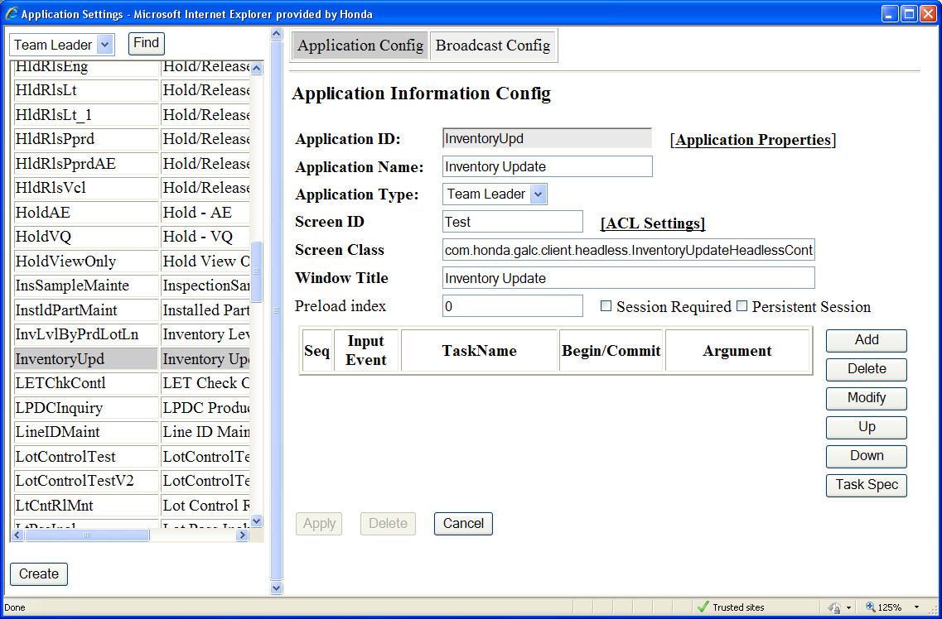

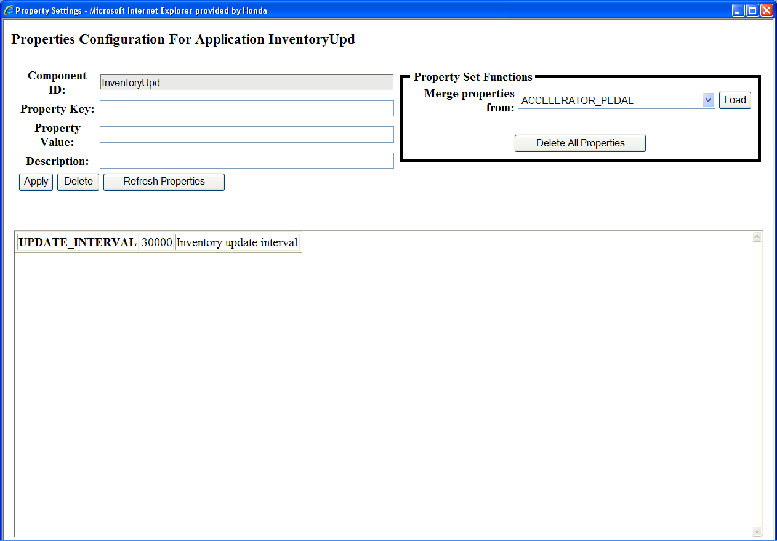

Purpose
The purpose of this station is to update paint plc with current inventory levels broken down by paint lines.

Major Tables
- GAL143TBX FRAME
- GAL195TBX LINE
- GAL214TBX PROCESS_POINT

Test Steps
This section describes the steps to be taken in order to execute the test.

Step | Procedure | Expected Results | Actual Results | Pass/Fail
1 | Start the EI_PA headless terminal in the DEV environment by executing the following command in CruiseControl:  enable-headless -Dterminal=ei_pa | No Errors are reported by CruiseControl after executing the command | No Errors reported by CruiseControl | Pass
2 | Verify that EI_PA terminal is running in the active AIX server by executing the following command:  ps -elf | fgrep EI_PA | EI_PA process should be returned by the command | EI_PA headless terminal is running | Pass
3 | Load the attached EI_PA.opf file to a Kepware Instance on XPP61413 | OPF file loaded successfully | No errors | Pass
4 | Start the OPC client to watch live updates to current inventory values | OPC client started successfully | No errors | Pass
5 | Execute the sql query in the attached CurrentInventory.sql file in the DEV environment | Query executes successfully | Query executed with no errors | Pass
6 | Verify that the inventory values for the paint departments match values returned by the query in Step 5 | Inventory values match | Inventory values match | Pass

Step 1
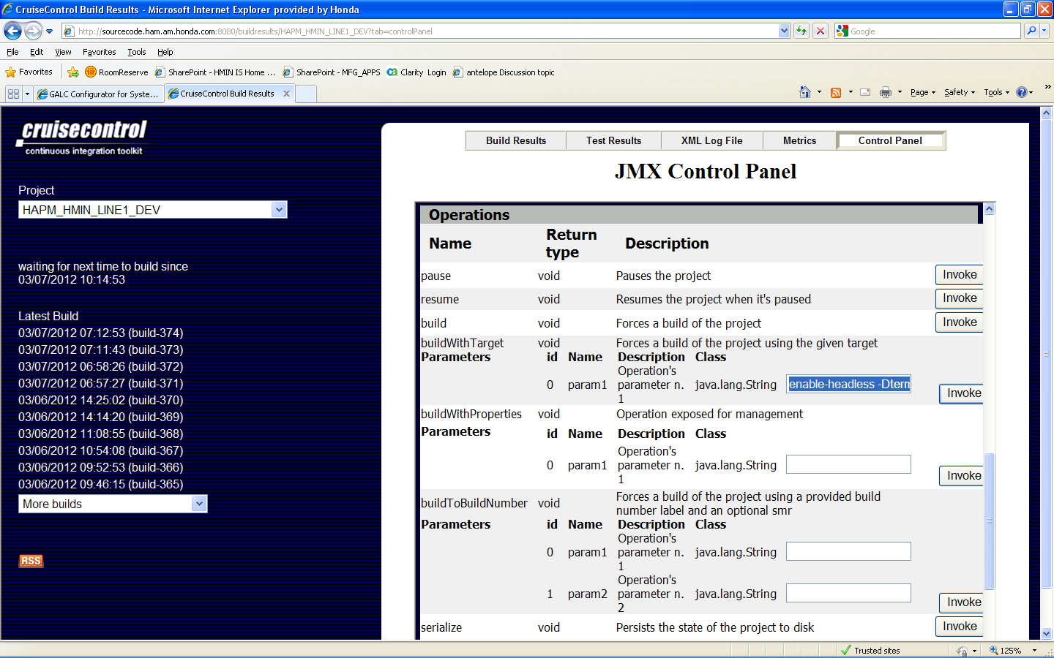

Step 2

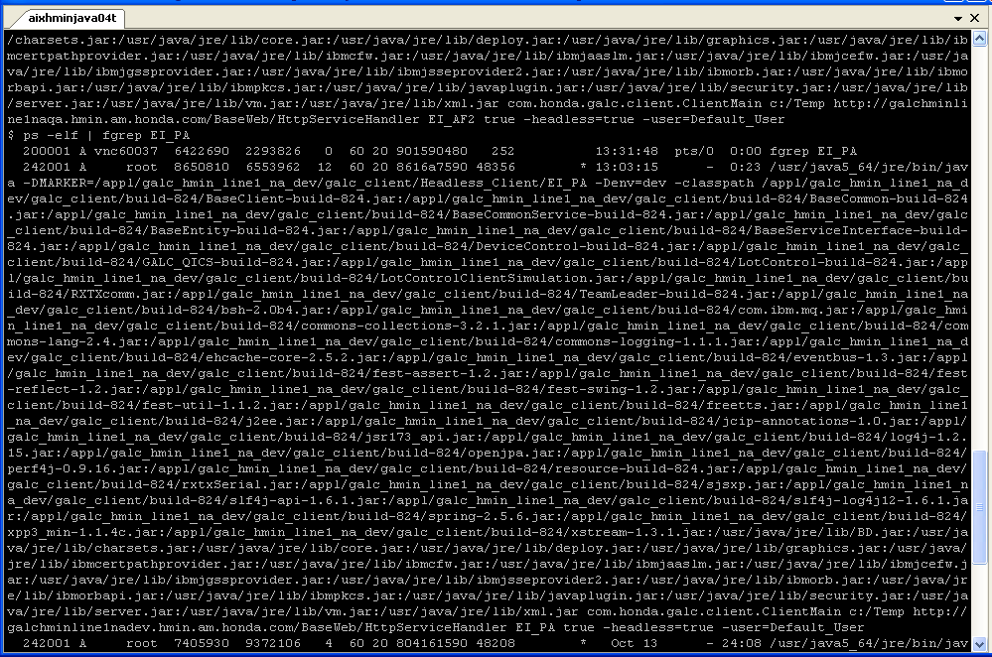

Step 3
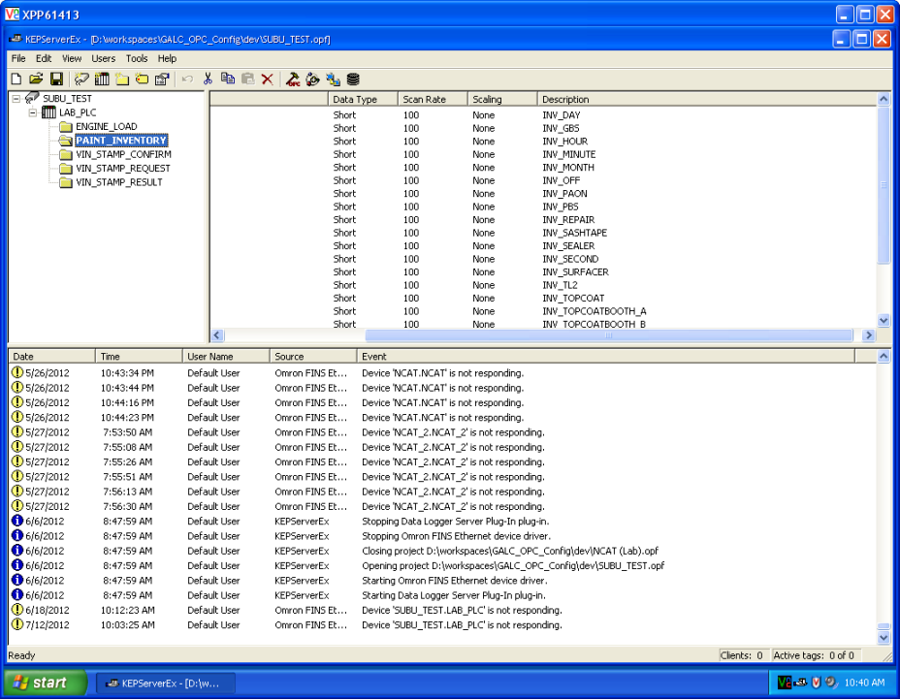

Step 4

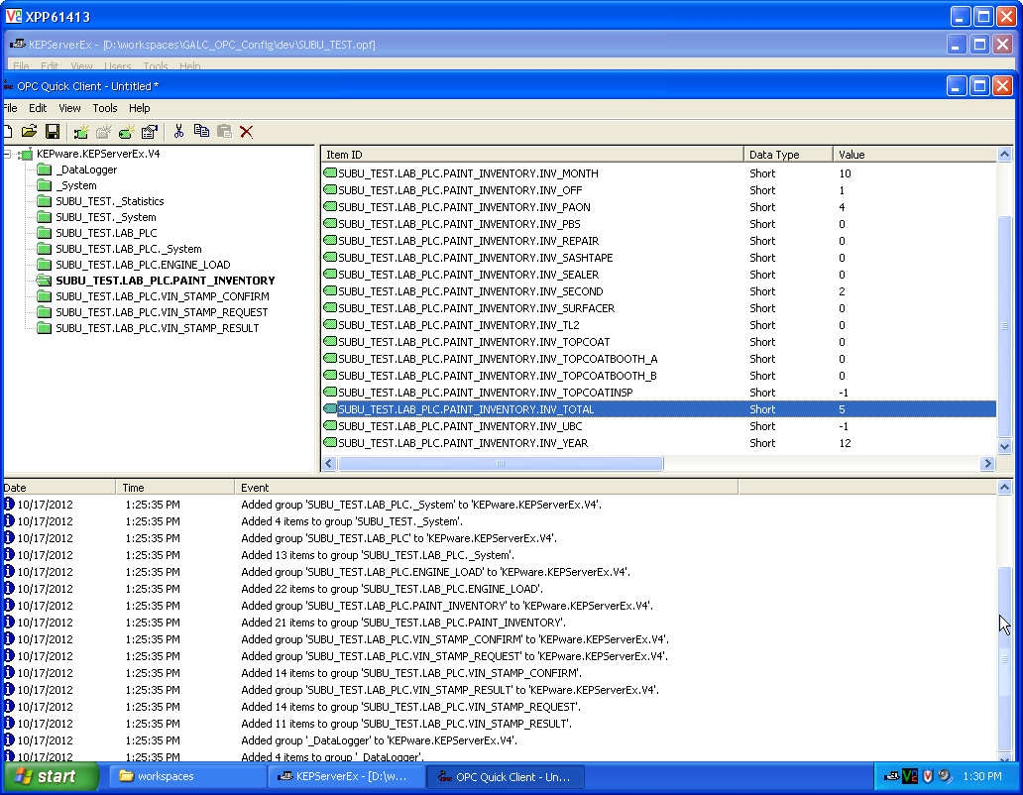

Step 5
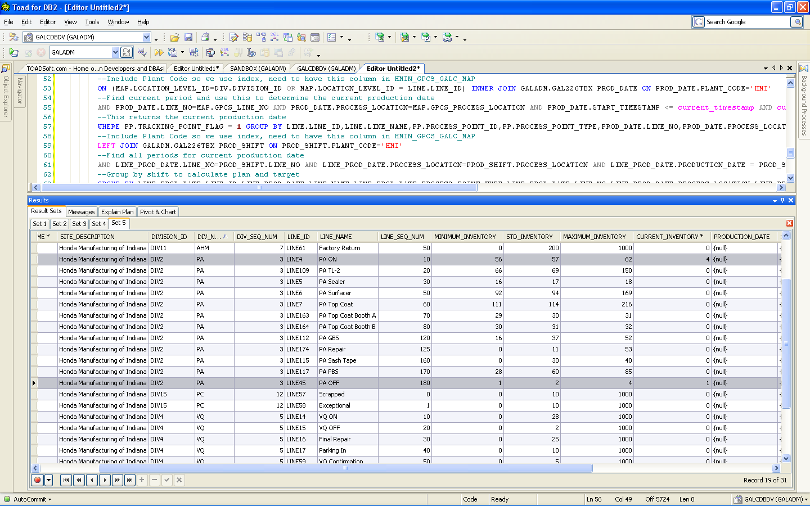

Post-Conditions
This section describes the steps to reset the test so that it can be executed multiple times. A post-condition is a condition or predicate that must always be true just after the execution of some section of code or after an operation in a formal specification. This may include such things as manually removing data or running a script to reset the test.
- None

Test Case 2 – Modify Inventory Update interval

Pre-Conditions
- The InventoryUpd application should be set up with the following properties

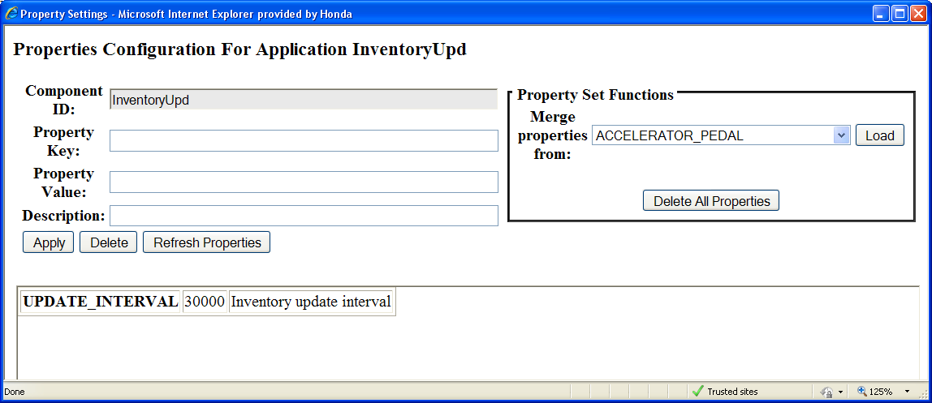

Purpose
The purpose of this test case is to modify the inventory update interval to the paint PLCs.

Major Tables
- GAL489TBX Properties

Test Steps
This section describes the steps to be taken in order to execute the test.

Step | Procedure | Expected Results | Actual Results | Pass/Fail
1 | Start the EI_PA headless terminal in the DEV environment by executing the following command in CruiseControl:  enable-headless -Dterminal=ei_pa | No Errors are reported by CruiseControl after executing the command | No Errors reported by CruiseControl | Pass
2 | Verify that EI_PA terminal is running in the active AIX server by executing the following command:  ps -elf | fgrep EI_PA | EI_PA process should be returned by the command | EI_PA headless terminal is running | Pass
3 | Load the attached EI_PA.opf file to a Kepware Instance on XPP61413 | OPF file loaded successfully | No errors | Pass
4 | Start the OPC client to watch live updates to current inventory values | OPC client started successfully | No errors | Pass
5 | Execute the sql query in the attached CurrentInventory.sql file in the DEV environment | Query executes successfully | Query executed with no errors | Pass
6 | Verify that the inventory values for the paint departments match values returned by the query in Step 5 | Inventory values match | Inventory values match | Pass
7 | Verify that the inventory values are updated every 30 seconds as specified by the “UPDATE_INTERVAL” property in the InventoryUpd application | Inventory values are updated every 30 seconds | Inventory values are updated every 30 seconds | Pass
8 | Change the “UPDATE_INTERVAL” property to 10000 | No errors | No errors | Pass
9 | Stop the EI_PA headless terminal in the DEV environment by executing the following command in CruiseControl:  disable-headless -Dterminal=ei_pa | No Errors are reported by CruiseControl after executing the command | No Errors are reported by CruiseControl after executing the command | Pass
10 | Start the EI_PA headless terminal in the DEV environment by executing the following command in CruiseControl:  enable-headless -Dterminal=ei_pa | No Errors are reported by CruiseControl after executing the command | No Errors are reported by CruiseControl after executing the command | Pass
11 | Verify that the inventory values are updated every 10 seconds | Inventory values are updated every 10 seconds | Inventory values are updated every 10 seconds | Pass

Step 8
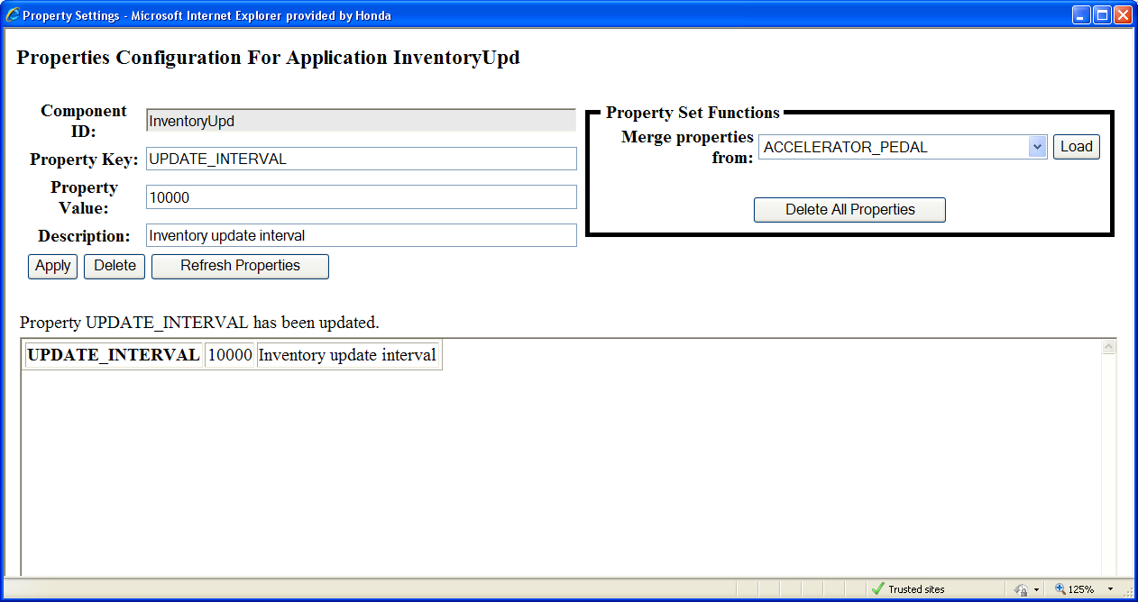

Step 11 (A)
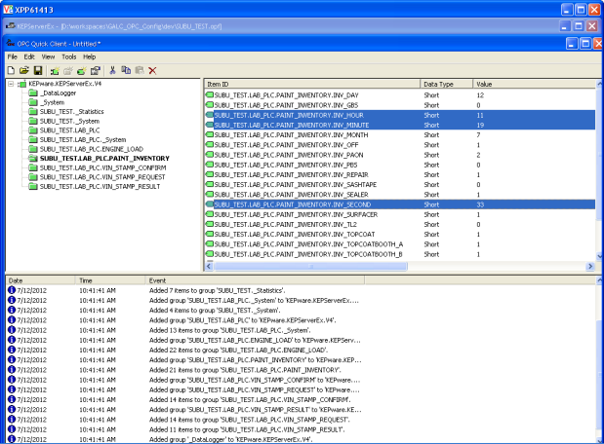

Step 11 (B)
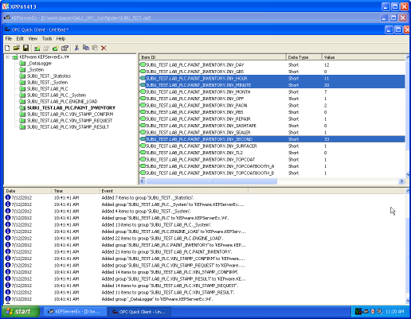

Post-Conditions
This section describes the steps to reset the test so that it can be executed multiple times. A post-condition is a condition or predicate that must always be true just after the execution of some section of code or after an operation in a formal specification. This may include such things as manually removing data or running a script to reset the test.
- None

